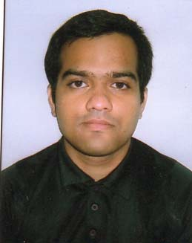 Bio Data

Persoanl Details :

Name -Turban Bose,

[e-mail-turbanbose@gmail.com](mailto:e-mail-turbanbose@gmail.com), Phone Number-9073272993,9547973028.

Knowledge-Website Template design in Photoshop, Custom design of Responsive Web-Site .

Qualification:-

Certificate course in PHP & My-Sql From Earth Technology Limited Kolkata2016-17.

Certificate course in Web-Design from ejob India(2015)Kollata.

Diploma in Financial Accounting From Brianware Chittarajan (2013).

Higher Secondary from (w.b.c.h.s.e) 2006 (Commerce).

Secondary from (W.B.S.E) 2004.

Knowledge in Web-Design & Development

HTML, CSS, Java-Script, J-query, Bootstrap, Photoshop, PHP & MySQL,

Other Details:-

1. Date Of Birth :-14/10/1987

2)Gender :-Male;

3)Fathers Name & Profession-Joydev Bose Railway Employee(retired 2016).